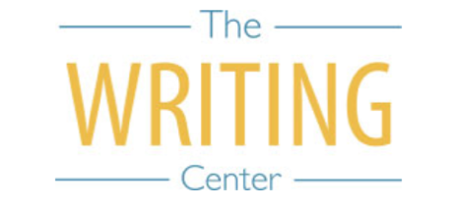 | 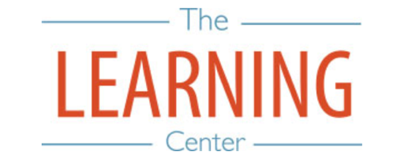

Summer Sessions I & II - 2026

Sunday Monday Tuesday Wednesday Thursday Friday Saturday
10 MAY | 11 | 12 | 13 SSI & Maymester Begin | 14 | 15 | 16
17 | 18 | 19 | 20 | 21 | 22 | 23
24 | 25 Holiday (Memorial Day) – No Classes | 26 | 27 | 28 Maymester Classes End/Exams | 29 Maymester Classes End/Exams | 30
31 | 1 JUNE | 2 | 3 | 4 | 5 | 6
7 | 8 | 9 | 10 | 11 | 12 | 13
14 | 15 | 16 SSI Classes End | 17 SSI Reading Day | 18 SSI Exam Day | 19 Holiday (Juneteenth) – No Classes | 20 SSI Exam Day
21 | 22 SSII Begins | 23 | 24 | 25 | 26 | 27
28 | 29 | 30 | 1 JULY | 2 | 3 Holiday (Fourth of July) – No Classes | 4
5 | 6 | 7 | 8 | 9 | 10 | 11
12 | 13 | 14 | 15 | 16 | 17 | 18
19 | 20 | 21 | 22 | 23 SSII Classes End | 24 SSII Reading Day | 25
26 | 27 SSII Exam Day | 28 SSII Exam Day | 29 | 30 | 31 | 1 AUGUST
2 | 3 | 4 | 5 | 6 | 7 | 8
9 | 10 | 11 | 12 | 13 | 14 | 15

The Writing & Learning Center / The University of North Carolina at Chapel Hill / writingcenter.unc.edu / learningcenter.unc.edu

