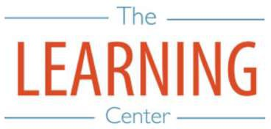
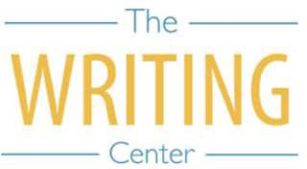
Spring Semester 2026

Sunday Monday Tuesday Wednesday Thursday Friday Saturday

4 JANUARY | 5 | 6 | 7 Classes begin | 8 | 9 | 10
11 | 12 | 13 | 14 | 15 | 16 | 17
18 | 19 Holiday (MLK Day) – No Classes | 20 | 21 | 22 | 23 | 24
25 | 26 | 27 | 28 | 29 | 30 | 31
1 FEBRUARY | 2 | 3 | 4 | 5 | 6 | 7
8 | 9 Well-Being Day – No Classes | 10 | 11 | 12 | 13 | 14
15 | 16 | 17 | 18 | 19 | 20 | 21
22 | 23 | 24 | 25 | 26 | 27 | 28
1 MARCH | 2 | 3 | 4 | 5 | 6 | 7
8 | 9 | 10 | 11 | 12 | 13 | 14 Spring Break
15 Spring Break | 16 Spring Break | 17 Spring Break | 18 Spring Break | 19 Spring Break | 20 Spring Break | 21 Spring Break
22 Spring Break | 23 Classes Resume | 24 | 25 | 26 | 27 | 28
29 | 30 | 31 | 1 APRIL | 2 Well-Being Day – No Classes | 3 Holiday – No Classes | 4
5 | 6 | 7 | 8 | 9 | 10 | 11
12 | 13 | 14 | 15 | 16 | 17 | 18
19 | 20 | 21 | 22 | 23 | 24 | 25
26 | 27 Classes end | 28 Reading Day | 29 Exams | 30 Exams | 1 MAY Reading Day | 2 Exams
3 | 4 Exams | 5 Exams | 6 Reading Day | 7 Exams | 8 | 9 Spring Commencement
10 | 11 | 12 | 13 | 14 | 15 | 16

The Writing & Learning Center / The University of North Carolina at Chapel Hill / writingcenter.unc.edu (919) 962-7710 learningcenter.unc.edu

