Semester Goals and Action Plan
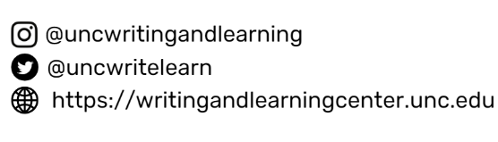
Consider broad goals this semester. What habits can you develop that will help create an overall positive experience (academically, socially, etc)? When you reach the end of the semester, what do you want to have accomplished and how do you want to feel? Use this worksheet to identify 3 broad goals. Keep this sheet where you’ll always see it, and refer to it when completing the Weekly Action Plan worksheet.

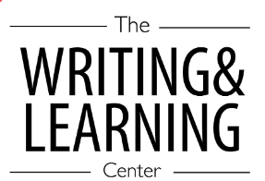

GOAL: | WHY IS THIS GOAL IMPORTANT?  How will progress on this goal  positively affect your life as a student at UNC? | BEHAVIOR CHANGE  To make progress on this goal, what behaviors might you need to change? What new behaviors might you need to include. | Make your goal SMART:  Specific, Measurable, Action-Oriented, Realistic and  Time-Sensitive
EX: I want to exercise regularly | Exercising gives me more energy and  helps me sleep better. With more energy and sleep, I’ll be more alert in classes and can study with more focus. | I can’t return to my room after classes  because I’ll be less likely to go to gym later. Instead, I’ll pack workout clothes in my backpack and go to gym directly after class. | I will go to gym 4X/week, doing a  combination of cardio and weights. I’ll ask a friend to join me to keep me motivated and accountable. I’ll keep a chart tallying my progress.
1.
2.
3.

This work is licensed under a Creative Commons Attribution-NonCommercial-NoDerivs 3.0 United States License. You may reproduce it for non-commercial use if you use the entire handout and attribute the source: The Learning Center, University of North Carolina at Chapel Hill.
Like This Handout?
Here’s More!

