 | Tasks for: ________________  (class) | Tasks for: ________________  (class) | Tasks for: ________________  (class) | Tasks for: ________________  (class) | Tasks for: ________________  (class)
Wed 12/3
Thu 12/4
Fri 12/5
Sat 12/6
Sun 12/7
Mon 12/8
Tue 12/9
Wed 12/10
Thu 12/11
Fri 12/12

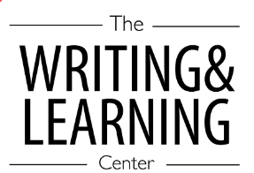
The Learning Center’s
Fall 2025 Final Exam Master Task Table
Spring 2023

