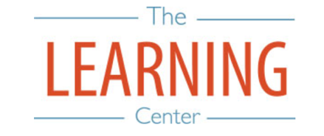
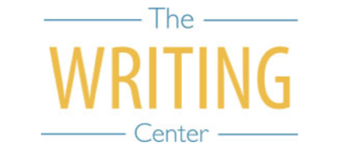

Fall Semester 2025

Sunday Monday Tuesday Wednesday Thursday Friday Saturday
3 AUGUST | 4 | 5 | 6 | 7 | 8 | 9
10 | 11 | 12 | 13 | 14 | 15 | 16
17 | 18 Classes Begin | 19 | 20 | 21 | 22 | 23
24 | 25 | 26 | 27 | 28 | 29 | 30
31 | 1 SEPTEMBER Holiday (Labor Day) – No Classes | 2 | 3 | 4 | 5 | 6
7 | 8 | 9 | 10 | 11 | 12 | 13
14 | 15 Well-Being Day – No Classes | 16 | 17 | 18 | 19 | 20
21 | 22 | 23 | 24 | 25 | 26 | 27
28 | 29 | 30 | 1 OCTOBER | 2 | 3 | 4
5 | 6 | 7 Well-Being Day – No Classes | 8 | 9 | 10 | 11
12 University Day (No classes held during ceremony) | 13 | 14 | 15 | 16 Fall Break | 17 Fall Break | 18 Fall Break
19 Fall Break | 20 | 21 | 22 | 23 | 24 | 25
26 | 27 | 28 | 29 | 30 | 31 | 1 NOVEMBER
2 | 3 | 4 | 5 | 6 | 7 | 8
9 | 10 | 11 | 12 | 13 | 14 | 15
16 | 17 | 18 | 19 | 20 | 21 | 22
23 | 24 | 25 | 26 Thanksgiving Recess | 27 Thanksgiving Recess | 28 Thanksgiving Recess | 29 Thanksgiving Recess
30 Thanksgiving Recess | 1 DECEMBER | 2 | 3 Classes End | 4 Reading Day | 5 Exams | 6 Exams
7 | 8 Exams | 9 Exams | 10 Reading Day | 11 Exams | 12 Exams | 13

The Writing & Learning Center / The University of North Carolina at Chapel Hill / writingcenter.unc.edu / learningcenter.unc.edu

